Experiment No. 6

Aim: Implementation of Exception Handling in Java.

- Problem Statement: Develop a BankAccount class that implements core banking
operations:
○ balanceEnquiry(): Displays the current account balance.
○ withdraw(): Deducts the specified amount from the account balance.
○ deposit(): Adds the specified amount to the account balance.
Implement user-defined exceptions:
a. LowBalanceException: Thrown when a withdrawal amount exceeds the available
balance.
b. NegativeNumberException: Thrown when attempting to deposit or withdraw a
negative amount.
Develop a Java application program that demonstrates these functionalities and properly
handles these exceptions using try-catch blocks

import java.util.Scanner;

class LowBalanceException extends Exception {
public LowBalanceException(String message) {
super(message);
}
}

class NegativeNumberException extends Exception {
public NegativeNumberException(String message) {
super(message);
}
}

class BankAccount {
private double balance;

public BankAccount(double initialBalance) {
this.balance = initialBalance;
}

public void balanceEnquiry() {
System.out.println("Current balance: " + balance);
}

public void withdraw(double amount) throws LowBalanceException, NegativeNumberException {
if (amount < 0) {
throw new NegativeNumberException("Cannot withdraw negative amount.");
}
if (amount > balance) {
throw new LowBalanceException("Insufficient balance.");
}
balance -= amount;
System.out.println("Withdrawal successful. New balance: " + balance);
}

public void deposit(double amount) throws NegativeNumberException {
if (amount < 0) {
throw new NegativeNumberException("Cannot deposit negative amount.");
}
balance += amount;
System.out.println("Deposit successful. New balance: " + balance);
}
}

public class BankApp {
public static void main(String[] args) {
Scanner sc = new Scanner(System.in);
BankAccount account = new BankAccount(1000);
while (true) {
System.out.println("\n1. Balance Enquiry\n2. Deposit\n3. Withdraw\n4. Exit");
System.out.print("Choose an option: ");
int choice = sc.nextInt();
try {
switch (choice) {
case 1:
account.balanceEnquiry();
break;
case 2:
System.out.print("Enter deposit amount: ");
double depositAmount = sc.nextDouble();
account.deposit(depositAmount);
break;
case 3:
System.out.print("Enter withdrawal amount: ");
double withdrawAmount = sc.nextDouble();
account.withdraw(withdrawAmount);
break;
case 4:
System.out.println("Exiting...");
sc.close();
return;
default:
System.out.println("Invalid option.");
}
} catch (LowBalanceException | NegativeNumberException e) {
System.out.println("Error: " + e.getMessage());
}
}
}
}

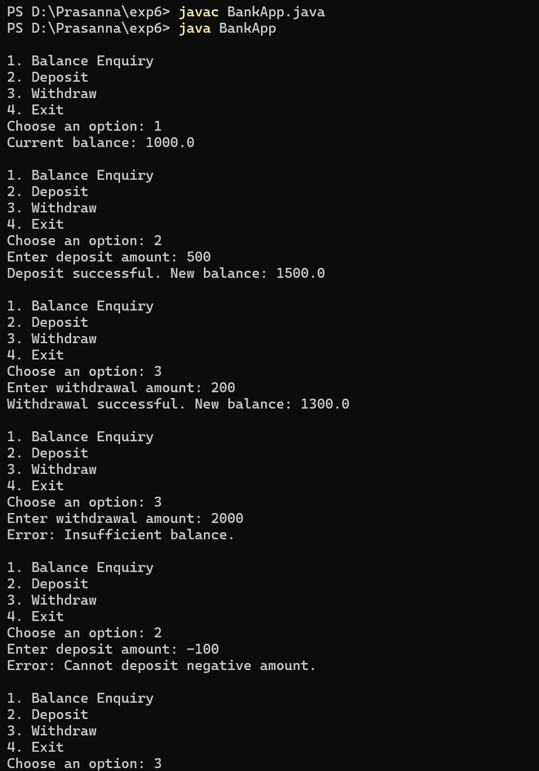
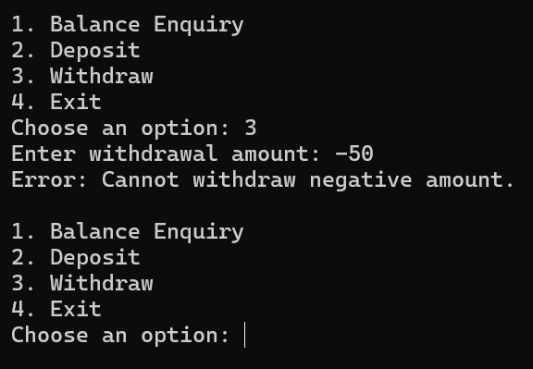

2. Write a Java program with a method that takes an integer as input. If the number is odd,
the method should throw a custom exception (OddNumberException). Handle this
exception in the main program
import java.util.Scanner;

class OddNumberException extends Exception {
public OddNumberException(String message) {
super(message);
}
}

public class OddNumberCheck {
public static void checkEven(int num) throws OddNumberException {
if (num % 2 != 0) {
throw new OddNumberException("The number " + num + " is odd.");
}
System.out.println("The number " + num + " is even.");
}

public static void main(String[] args) {
Scanner sc = new Scanner(System.in);
System.out.print("Enter an integer: ");
int number = sc.nextInt();
try {
checkEven(number);
} catch (OddNumberException e) {
System.out.println("Exception caught: " + e.getMessage());
}
sc.close();
}
}

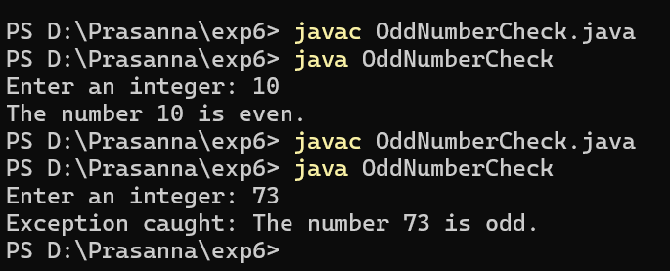

3.Create a package ExceptionHandlingDemo containing classes Calculator and DivisionException. ○ The Calculator class should have a method divide(int a, int b) that performs division. ○ If b is zero, throw a custom exception DivisionException with an appropriate error message. ○ Handle the exception in the main program and display an error message instead of crashing.

ExceptionHandlingDemo/
│
├─ Calculator.java
├─ DivisionException.java
└─ MainProgram.java

// Calculator.java
package ExceptionHandlingDemo;

public class Calculator {
public int divide(int a, int b) throws DivisionException {
if (b == 0) {
throw new DivisionException("Division by zero is not allowed.");
}
return a / b;
}
}

//DivisionException.java

package ExceptionHandlingDemo;

public class DivisionException extends Exception {
public DivisionException(String message) {
super(message);
}
}

// MainProgram.java
package ExceptionHandlingDemo;

import java.util.Scanner;

public class MainProgram {
public static void main(String[] args) {
Scanner sc = new Scanner(System.in);
Calculator calc = new Calculator();
System.out.print("Enter numerator: ");
int a = sc.nextInt();
System.out.print("Enter denominator: ");
int b = sc.nextInt();
try {
int result = calc.divide(a, b);
System.out.println("Result: " + result);
} catch (DivisionException e) {
System.out.println("Error: " + e.getMessage());
}
sc.close();
}
}

